UBND HUYỆN KIM THÀNH  TRƯỜNG TIỂU HỌC TUẤN VIỆT  (Đề chính thức) | ĐỀ KIỂM TRA CUỐI HỌC KỲ I  MÔN TIẾNG ANH LỚP 5  NĂM HỌC 2024 - 2025  (Thời gian : 35 phút)
Full name: .................................................... Class: .............
Listening |  |  | Reading |  |  | Writing |  | Speaking | Total
Q1 | Q2 | Q3 | Q4 | Q5 | Q6 | Q7 | Q8 | Q9

PART I: LISTENING (3 POINTS)
Question 1. Listen and number (1point)
 |  |  | 
A. | B. | C. | D.

Question 2. Listen and match a name with a picture (1 point)
1.  | 2.  | 3.  | 4.
A. 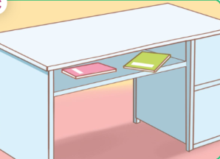 | B. 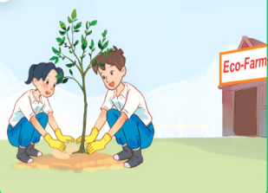 | C.  | D. 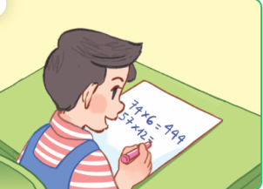

Question 3. Listen and tick True or False (1point)
 |  | True | False
1 | They were at the funfair last Sunday.
2 | In the morning, they walked around the lake.
3 | In the afternoon, they visited the zoo near the campsite.
4 | In the evening, they played the guitar and danced around the campfire.
PART II: READING (3 POINTS)
Question 4. Look, read and circle the correct answer (1point)
1. Where are the pens?  They’re....................................  a. beside the clock.  b. in front of the clock.  c. next to the clock. | 
2. What school activity does he like?  He likes ........................................  a. reading books  b. doing projects  c. solving maths problems | 
3. What would you like to be in the future?  I’d like to be a .......................................  a. writer  b. firefighter  c. gardener | 
4. Where’s the computer room?  It’s on ...........................................................  a. the ground floor  b. the first floor  c. the second floor | 

Question 5. Read the passage and circle the correct answers (1 point)
Hello. I am Tuan. I live with my parents in Ha Noi. I am in Class 5A at Nguyen Du Primary School. The school is near my house. There are three buildings at my school. My classroom is in Building C. Minh is my best friend. He lives near our school. His address is Nguyen Du Street, Ha Noi.
1. Tuan’s home is ................................. his school.
a. near | b. far from
2. His school is in ................................................
a. Building A | b. Building C
3. His best friend lives near .................................
a. the school | b. his home
4. Minh’s address is ..............................................
a. Nguyen Du Street, Nam Dinh. | b. Nguyen Du Street, Ha Noi.
Question 6. Read and choose the words from the box to complete the passage (1 point).
on | crayons | surfing the Internet | bookcase

Kate likes (1) .............................................................. in her free time. She has a new computer. That is her computer. It is (2) ....................... the desk. She also loves drawing pictures. She usually draws pictures at the weekend. She has some (3) ............................. on the desk. She uses them to draw pictures. Her new pictures are beside the (4) ........................................... They’re beautiful.
PART III: WRITING (2 POINTS)
Question 7: Order the words. There is one example. (1 point)

Example: | you / What / do / like/ school activity /?  --> What school activity do you like?

1. father / likes / football / My /his free time./ in / playing /
_______________________________________________________________________.
2. classroom/ My/ is/ the second/ on/ floor.
________________________________________________________________________
3. I would like/ because / help / a firefighter / I want to / people. / to be / ________________________________________________________________________
________________________________________________________________________4. the / pencil case/ beside / His /crayons / are/ ________________________________________________________________________
Question 8. Write a passage about your personality (1point)

My name’s________ I live in________________. I’m in class______________
My favourite subject is____________. My favourite school activity is____________
I’d like to be _______________ in the future.
Question 9. Speaking (2points)

The end

Giáo viên coi thi:……………………….. Giáo viên chấm thi: ……………………….

